# Raspberry Pi RFID Movie Player

## Instructions for use

Document version

|  |  |
| --- | --- |
| **Date - Ver - Comments** | **Updated By** |
| 7 Dec 2019 - 1.0 - Initial document | Peg Leg |
|  |  |
|  |  |
|  |  |

Contents

Raspberry Pi RFID Movie Player 1

Instructions for use 1

Connecting the player and powering up 2

Boot up 2

Affix RFID stickers to your DVD boxes 3

Associating movies with an RFID tag 4

Pausing, unpausing and changing movies 5

Resetting the player 6

Technical and troubleshooting 7

The buttons aren't working 7

The reset button does nothing 7

## Connecting the player and powering up

The player is powered by a 5v Raspberry Pi charger with 2.5a capacity (Micro USB). The cable is connected to the Raspberry Pi internally and exits the player at the back next to the fan along with the HDMI output cable.

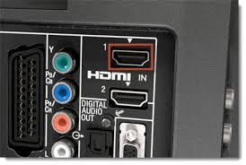**Connect the HDMI cable to the HDMI input of your TV and turn the TV on (switch it to HDMI mode)**. You can also source and use third party adapters if your TV / monitor does not support HDMI).

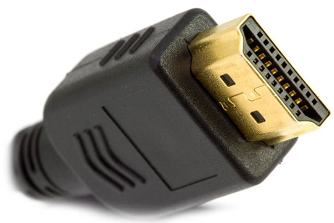

🡪

**Connect the Raspberry Pi Power adapter to a 2-pin power outlet**.

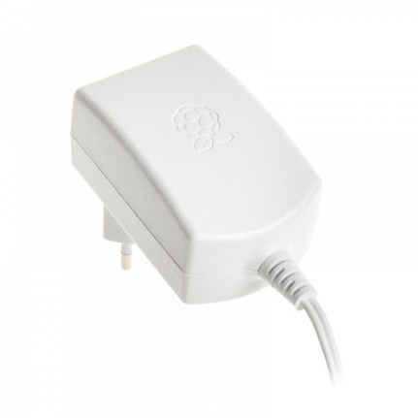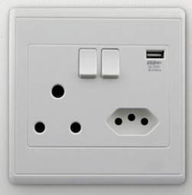

🡪

The Raspberry Pi will boot automatically and remain on as long as the adapter is powered. The Pi is a low powered device - like most mobile phones - and is not costly to leave running 24x7. The only risk to the unit is power fluctuations and spikes / surges. Ideally the adapter should be connected to a surge arrestor as with any sensitive electronic equipment. Most insurance companies cover computer hardware for events such as surge or lightning damage under their specified section.

### Boot up

When turned on, the Raspberry Pi logo appears at the top left of the screen and after some seconds, the 'idle' banner shows - prompting the user to place a DVD on the tray:

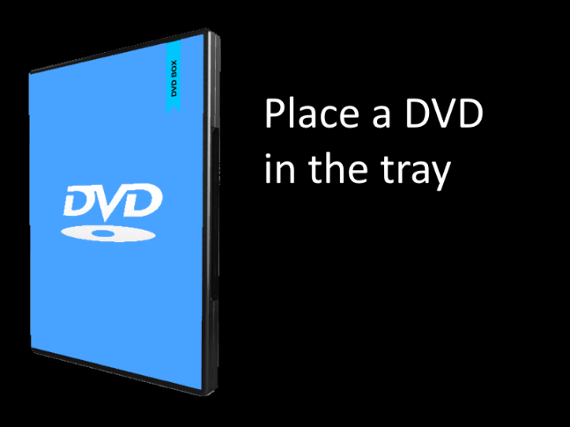

🡪

Note that on some TVs, if you boot up the system while the TV is not connected or powered off, the resolution may appear odd when you turn it on (or nothing might display on the screen). This shouldn’t happen on most systems but may on some. It is easily fixed by pressing the reset button on the player while the TV is connected and turned on. Either way, the system will not be affected by powering the TV off and then on again (or changing channels) after the it has started up. An easy test to see if this would be the case on your system is to power the TV and player off and turn the player on for 30 seconds before turning the TV on.

### Affix RFID stickers to your DVD boxes

This Raspberry Pi based RFID media player uses the MFRC522 RFID reader which operates at 13.56MHz and thus requires 13.56MHz tags (often called **MIFARE** tags). While MIFARE tags are capable of recording user supplied data in addition to their unique ID, in this player they are only used for their unique ID. The reason the MFRC522 player was used over other readers is because of the solid build, availability and low cost of the reader.

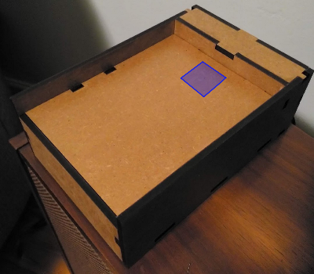Each RFID tag (sticker) has a unique ID - no two are the same. The way the system works, is to read the tag and allow the user to associate it with a particular movie file stored on a USB storage device connected to the Raspberry Pi. Once a tag is associated with a movie file, each time the box with that tag is placed in the tray, the system reads the tag ID and looks up the movie name and starts playing that movie.

The reader is located under the upper tray at the middle of the front of the player as indicated in blue:

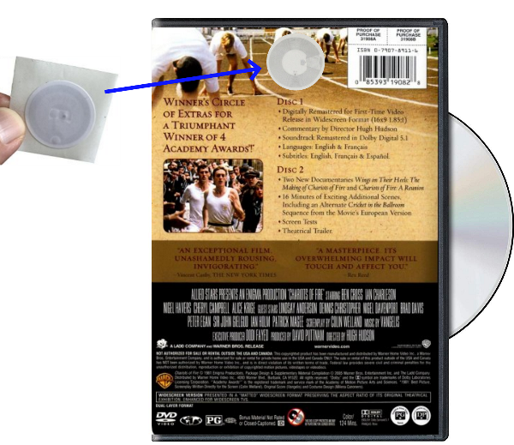Place at least one RFID sticker on your DVD boxes, preferably at the back of the box near the top middle as indicated in the image. To avoid wear and tear to the RFID tag, preferably place the sticker onto the printed insert under the transparent plastic outer cover or underneath the printed insert onto the plastic case - whichever is easier.

If you feel it's necessary, to make it easier for the user, you can place another tag on the front as well - a single movie can be associated with multiple tags. Up to 4 tags can be placed on the DVD box if necessary - two at the top (front and back) and two at the bottom (front and back).

### Associating movies with an RFID tag

Associating a tag with a movie file is a once-off process and unless you want to associate a tag with a different movie file or you later replace the USB drive with another, you should not have to go through this process again for an already identified movie - you would simply place your movie box onto the scanner to play it.

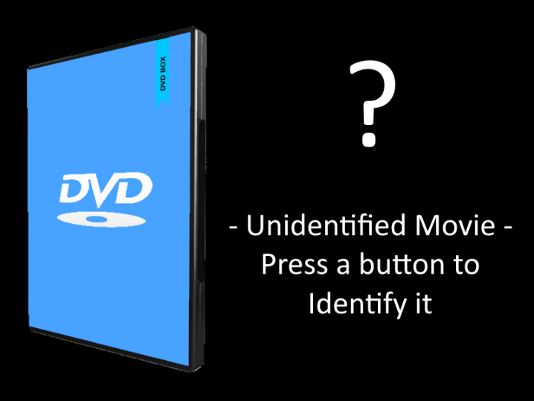The data file that stores the unique tag number against the movie name is stored in the main operating system on the Raspberry Pi's Micro SD card. The movie name is not stored on the RFID tag - the tag's only purpose is to uniquely identify the box.

Place the DVD box in the tray. If the movie has not yet been associated with this box / tag, then the 'Unknown Movie' banner is shown:

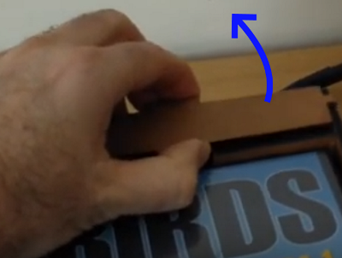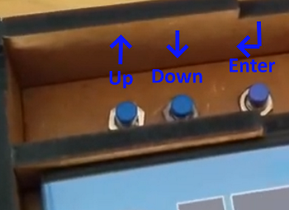To identify the movie, **remove the top cover** hiding the 3 control panel buttons. The left most button is up, the middle is down and the right most button is 'Enter' or 'select'. From the banner screen, **press the Enter button** first to remove the banner, **then press either up or down to bring up the maintenance menu** (it may take up to two seconds after a key is pressed for the menu to pop up). Ignore the text that appears on the black screen after the banner is dismissed - this is merely a quirk that has not been ironed out yet.

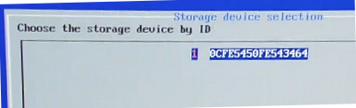At the maintenance menu, use the **up and down** buttons to select '**Link a movie to the last scanned tag**' followed by the '**Enter**' button. On the second menu screen, **select the USB device** your movies are stored on. If you only have one USB drive attached, only device one will appear in the list. The device's unique ID is used to identify the device to ensure that the device is uniquely identified even if the label changes and even though multiple devices can share the same label. 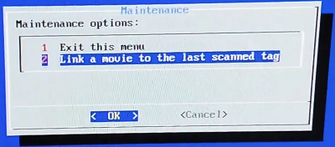

On the final screen, **select the movie** you want to associate with this tag / box and **press Enter**:

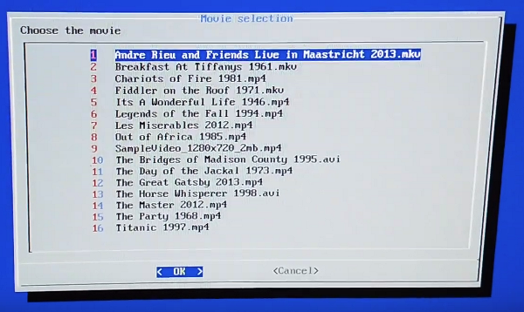

Right after selecting the movie, it will begin playing. **If you made an error** in selection, simply **press the up or down** **buttons** while the movie is playing to bring the menu up again and select another movie instead.

If you decided to use more than one tag with your movie boxes, turn the box over or around to associate the other tags with the same movie.

### Pausing, unpausing and changing movies

As long as the box remains on the scanner, the movie associated with it will play. To pause the movie, simply move the tag box off the scanner. The movie will pause within around 4 seconds. The movie will remain paused until the same tag is placed back on the scanner.

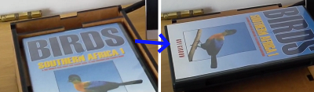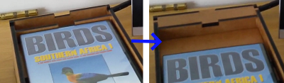

*or*

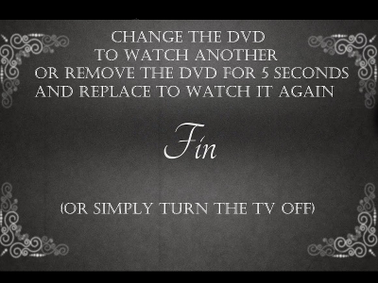 To change the movie, simply take the box off the scanner and place the new movie on. Once a movie has finished playing, the 'Fin' banner appears:

As explained in the banner, removing the DVD for 5 seconds and placing it back on the tray will replay the movie, while changing the box will start the new movie.

Note: The TV can be turned off at any time. There's no need to stop a movie that is paused if you want to turn the TV off. Since there is no physical media playing, there is no strain on the system if a movie is left in a paused state when turning the screen off. If this is a difficult concept for the user and they prefer to 'stop the movie', they can simply remove the DVD from the tray and press the reset button at the back of the player and then turn the screen off. The system will simply reboot and wait for a new movie to be placed while on the 'idle' banner.

### Resetting the player

To reset the player for any reason - including in the rare case that it hangs or misbehaves - simply press the reset button at the rear of the player:

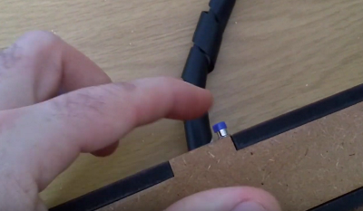

## Technical and troubleshooting

This section is typically reserved for the more technically inclined.

### The buttons aren't working

The buttons are connected to the Raspberry Pi via the GPIO connector pins 5, 6 and 13 (Broadcom numbers) which correspond with physical pins 29, 31 and 33 of the 40 pin connector. Refer to the hardware installation guide and ensure you have connected the buttons up correctly.

Ensure that you are using 'press to make' type reset buttons which only make contact when you press them. One pin from the button connects to ground and the other to the appropriate GPIO pin of the Raspberry Pi GPIO connector. Effectively, pressing the button, you are bridging the GPIO pin with ground.

Ensure that during the installation process, you opted to install the retrogame application and configuration file which is used to translate button presses to keyboard actions. If you are unsure, then follow the steps in the installation manual to do so. Running the automated installation script from the beginning will be safe provided you haven't modified the application or any of the scripts in any way. Alternatively, follow the manual steps to install retrogame from the installation menu.

An alternative to using buttons is to connect a USB wireless keyboard dongle to the raspberry pi and use the wireless keyboard instead. The retrogame library is not required to use a keyboard but having it installed won't affect the system.

### The reset button does nothing

The reset button is a simple 'press to make' button that bridges the 'run' pin on the Raspberry Pi 3B+ or higher to ground, which causes it to reset. This may be different on a Raspberry Pi 2 or earlier Pi 3. Ensure that one side of the button is connected to ground and the other to the 'run' pin on the bard. Note that there is by default no header soldered to the board so you would have to solder one on yourself or solder a cable directly to the board with the other end soldered to the reset button.